Name : Md. Samim Hossain
ID : IT-17033
Lab No : 01
Name of the lab :Network configuration, Routing table and Virtual interfaces

Objectives : (i)Finding IP and MAC address
(ii)Routing Table Basics
(iii)Virtual interfaces
(iv)Adding a Network
(v)Multinetworking Scenario Configuration

1) Introduction :
If you have a network that ranges from 192.168.1.0 to 192.168.1.255 explain why individual devices in the network can only be assigned IP addresses in the range of 192.168.1.1 to 192.168.1.254.

Ans:

Ipv4-addresses are internally 32 bits, for it being easier to read for humans, they are often divided into 4 groups of 8 bits.

8 bits converted to decimal can range from 0 to 255. because
0 | 0 | 0 | 0 | 0 | 0 | 0 | 0
means 0
1 | 1 | 1 | 1 | 1 | 1 | 1 | 1
means 255
It means that all addresses in the ranges of 192.168.1.0 to 192.168.1.255 are in the same network. In all networks, the first address and last address is unusable, so the first usable address is 192.168.1.1 and the last is 192.168.1.254.
Since all devices in the network need to have unique addresses that means that you can have 254 devices in that network.
In the network, generally one address is the default gateway, the router that connects that sub net to the rest of the world. That can be anyone of those 254 addresses, but the most common ones are .1 and 254.

2)Find IP and MAC :
Write down the IP and MAC address of your computer ?
Ans:
We can find our device IP address using “$ip address’’ Command in Linux terminal.
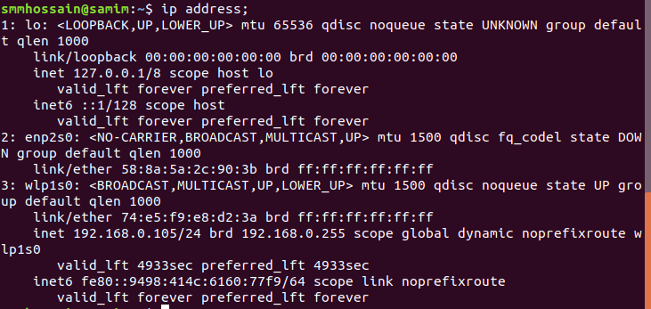
We can also find our local computer IP address using $hostname -i ’’ command in Linux terminal
MAC address is the physical address of computer. We can find MAC address using “$ifconfig’’ command in Linux terminal. Before using this command we have need some tools. To install these tools we have to write “$sudo apt install net -tools ’’. Then we can find MAC address using “$ifconfig” command.
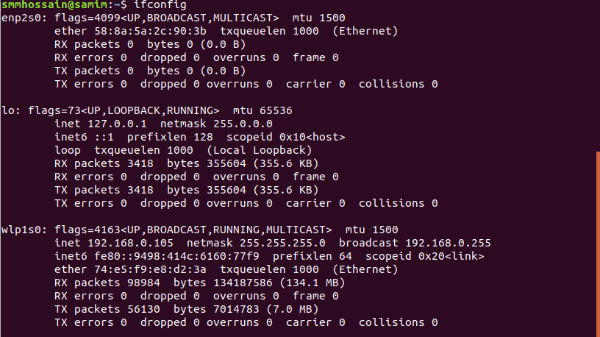
3)Routing Table Basics :
Enter the command : “$ netstat -r “ to print my computer’s routing table.
We can also see our computers routing table using “$netstat -r -n’’ and “$route -n’’ command in Linux terminal.
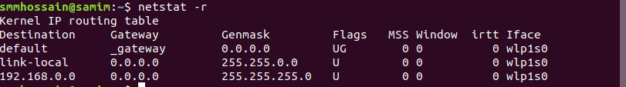
- Destination : The destination network or destination host.
- Gateway : The gateway address or â€™*â€™ if none set.
- Genmask : The netmask for the destination net; 255.255.255.255 for a host destination and 0.0.0.0 for the default route.
- Flags : Possible flags include
  - U (route is up)
  - H (target is a host)
  - G (use gateway)
- MSS : Default maximum segment size for TCP connections over this route.
- Window : Default window size for TCP connections over this route.
- irtt : Initial RTT (Round Trip Time). The kernel uses this to guess about the best TCP
- Iface : Interface to which packets for this route will be sent.

4) Virtual interfaces :
a) Create a new virtual interface with the following IP address , 192.168.2.32 and netmask 255.255.255.0 then check to see if the interface was created successfully?
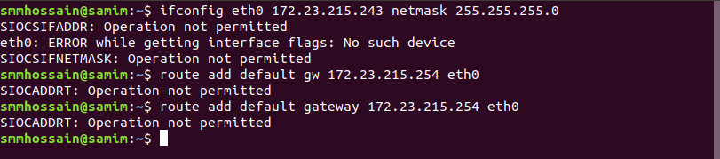
b)You need to set up a route for this interface so that your computer can see it.Issue the needed command ,then issue the “$ netstat -r” command and check if the route to your added interface is visible?
c)Next remove the route for this interface ?
d) Then remove the interface completely ?
Ans :To disable our temporary network interface created earlier we can use the ifconfig command again but with a down flag.
5) Add a New network :
a) Enter the command needed to add another network with the same values as your primary network meaning : (yourPrimaryNetworkAddress) and (netmaskforYourNetwork) .

b)Assign the default gateway for newly added network(YourdefaultGateway Address)

c)Look for your newly added network in your routing table by issuing the “$ netstat -r “ command.

d) Now remove your chnages meaning the double routing table setup for your primary network . First issue the command needed to delete your newly added route then issue the command to delete you newly added default gateway.
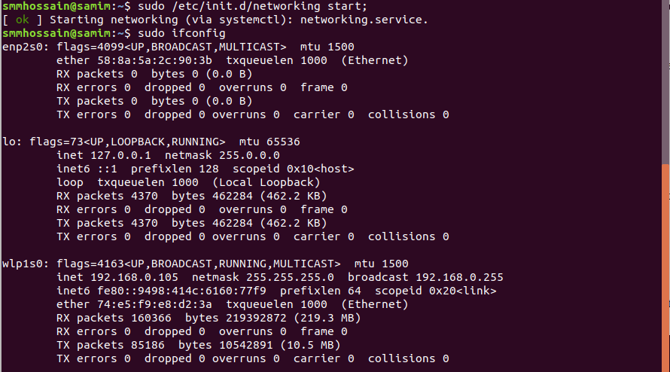
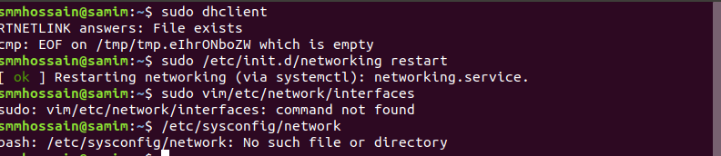
6)Multinetwork scenario configuration :
We should now set up a working routing table for a multi-network scenario . Assume that we have two network cards available connected to two different LANs . The destination of the first network is, 10.0.2.0 with netmask 255.0.0.0 and the second, 192.168.1.0 with netmask 255.255.255.0 ,Furthermore , a firewall is assumed to exist between the two networks , where network card eth0 is attached to the 10.0.2.0 network and eth1 is attached to the 192.168.1.0 network.To forward packets on the internet the firewall needs to route packets from the 10.0.2.0 network through the 192.168.1.0 network . The firewall system must be set up with two IP addresses ,10.0.2.1 on eth0 and 192.168.1.25 on eth1 . The gateway to the internet on the 192.168.1.0 network should be 192.168.1.1 .
Provide the necessary commands to route on the firewall/router system.
a) Assign the firewall IP addresses to eth1 and eth2 .
b)Add the routes for the networks , i.e, 192.168.1.0 on eth1 and 10.0.2.0 on eth0
c)Assign the internet gateway(meaning : 192.168.1.1) as the default gateway .
d)Enter the necessary commands in order for packets belonging to computers in the 10.0.2.0 network to be routed to the 192.168.1.0 network and the internet . In other words this should tell each computer on the 10.0.2.0 , which the default gateway is , i.e.., your firewall/router. You do not need to be worry about the route back configuration it is enough to assign the proper default gateway for the 10.0.2.0 network.

